Sum of Elements in dart

Exercise #3

Flutter Developer Bootcamp

# **Purpose**

This Exercise demonstrates how to use Dart's List class and its methods to generate a list of integers and then calculate the sum of those integers using the reduce method

**Problem**

In the provided Exercise You need to create as follows:

This Exercise generates a list of integers from 1 to 10, calculates their sum, and prints both the list and the sum.

**How to Solve**

1. Checkout the Exercise from Git Repo:

git clone -b <user-branch> <repo-URL>

2. Open the root folder inside VS Code

3. Open the root folder in terminal

4. Run the command dart run filename.dart

5. List Generation:Initialize a list called numbers. It generates a list containing integers from 1 to 10 using the List.generate method. The List.generate method takes two arguments: the length of the list (which is 10 in this case) and a function that generates each element. The function (index) => index + 1 generates numbers starting from 1 and increments by 1 for each subsequent element.

6. Sum Calculation:Calculates the sum of all elements in the numbers list using the reduce method. The reduce method takes a binary function as an argument, which combines two elements at a time. In this case, the lambda function (value, element) => value + element adds each element to the accumulator value, starting from the first element. The result is stored in the variable sum.

7. Printing Results:Print the generated list of numbers and the sum of all elements to the console. The $numbers and $sum are placeholders that get replaced by the actual values of the numbers list and sum variable, respectively.

8. Go To File: <specific-file-with-Sum-method> à <method-name>, implement your logic.

**You will Achieve**

When you complete this Exercise you will learn the following:

* **List Generation:** The List.generate function is used to create a list of integers from 1 to 10.
* **Sum Calculation:** The reduce method is applied to calculate the sum of all elements in the list.
* **Printing Results:** The print function is used to display both the generated list and the sum of its elements.

# **Screenshots**

## **Expected output (with Sum of Elements)**

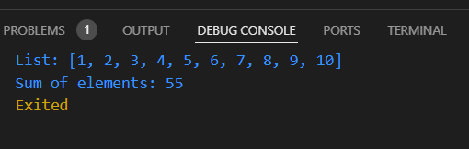

## 

# **How to submit your Exercise**

Push your project back to the same git branch using command:

<command name>

# **Happy Coding!**